18ECC350T-Comprehension

Microwave and Optical Communication System

1. Telegraphers equation, propagation constant, Characteristic Impedance, Reflection Coefficient , VSWR and Impedance Transformation relation in a Transmission Line,
2. Rectangular waveguide, Modes of Operation, Transverse Electric (TE), Transverse Magnetic (TM), Transverse Electric and Magnetic(TEM), HYBRID (HE)
3. Optical Fiber Sources and Detectors.
4. Light Propagation in Optical Fiber, Types of Fiber based on refractive index profile and mode of transmission
5. Nonlinearity and dispersion in optical signal transmission.

MCQ’S

**1. Telegraphers equation, propagation constant, Characteristic Impedance, Reflection Coefficient ,VSWR and Impedance Transformation relation in a Transmission Line**

**MCQ-1**

All signal frequencies are propagate in a transmission line at same speed than characteristic impedance of a transmission line is ______.

1. Purely capacitive
2. Purely resistive
3. Purely inductive
4. None of the above

Solution: 2. Purely resistive

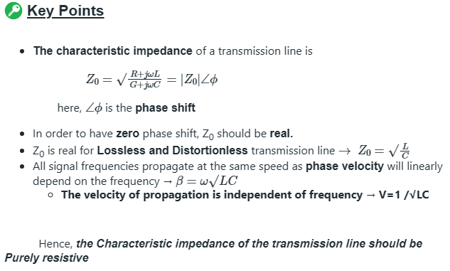

**MCQ-2**

The intrinsic impedance of free space is _______

1. 107 Ω
2. 214 Ω
3. 377 Ω
4. 754 Ω

Solution: 3. 377 Ω

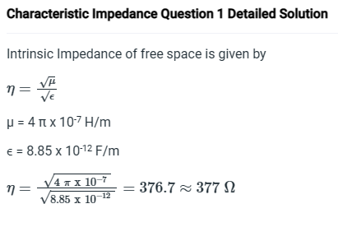

**MCQ-3**

A parallel plate lossless transmission line consists of brass strips of width ‘w’ and separated by a distance ‘d’. If both ‘w’ and ‘d’ are doubled then its characteristic impedance will be _______ ?

1. halved
2. doubled
3. not change
4. none of these

Solution: 3.not change

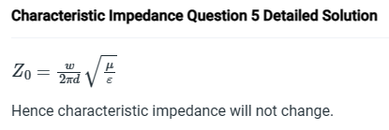

**MCQ-4**

The Characteristic Impedance of a low pass filter in attenuation Band is _______ ?

1. 0
2. Real value
3. Complex quantity
4. Purely imaginary

Solution: 4. Purely imaginary

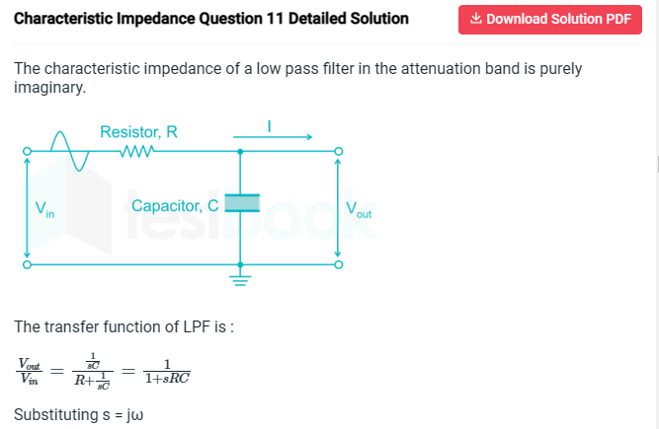

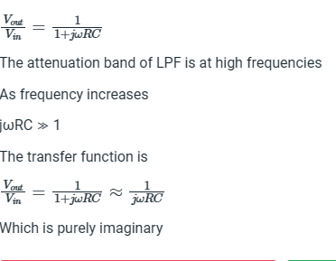

**MCQ-5**

A transmission line having Z0 =75 Ω is used to deliver power to 300 Ω load.  
The VSWR of circuit is?

1. 0.25
2. 4
3. 0.5
4. 2

Solution: 2. 4. (Four)

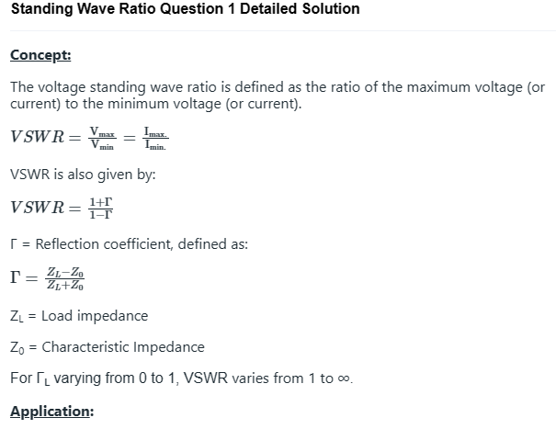

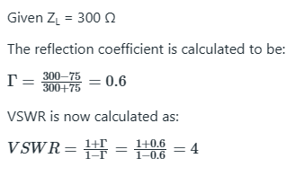

**MCQ-6**

Find the VSWR, if the reflection coefficient is 0.8 ?

1. 4.5
2. 18
3. 5
4. 9

Solution: 4. 9. (Nine)

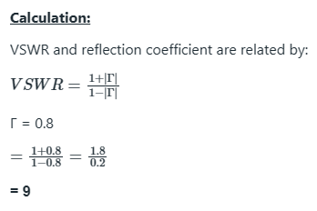

1. **Rectangular waveguide, Modes of Operation, Transverse Electric (TE), Transverse Magnetic (TM), Transverse Electric and Magnetic(TEM), HYBRID (HE)**

**MCQ-1**

The Waveguide only allows frequencies _______ the cutoff frequencies

1. Below
2. Above
3. Equal to
4. None of these

**MCQ-2**

The energy in a waveguide is ____ , when no propagating mode inside the waveguide

1. Zero
2. Positive
3. Infinite
4. Negative

**MCQ-3**

The average power flow down the waveguide below cutoff frequency is _______

1. Zero
2. Positive
3. Infinite
4. Negative

**Answer: MCQ-1=2(Above); MCQ-2=1(Zero); MCQ-3=1(Zero)**

Solution:

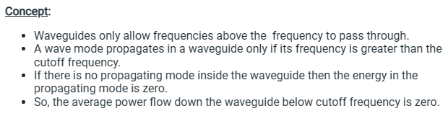

**MCQ-4**

The real part of propagation constant shows

1. Attenuation constant
2. Phase constant
3. Reduction of only voltage amplitude
4. Variation of voltage and current on basic unit

Solution: attenuation constant

**MCQ-5**

The waveguide can be considered as

1. High pass filter
2. Low pass filter
3. Band pass filter
4. None of these

Solution: HPF

**MCQ-6**

If in a rectangular waveguie for which a=2b, the cut-off frequency for TE02 mode is 12GHz, the cut-off frequency for TM11 mode is

1. 3 GHz
2. 3 $\sqrt{5}$ GHz
3. 6 $\sqrt{5}$ GHz
4. 12 GHz

Solution: 3 $\sqrt{5}$ GHz

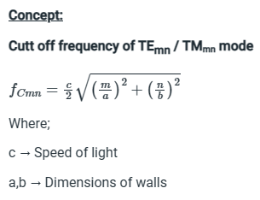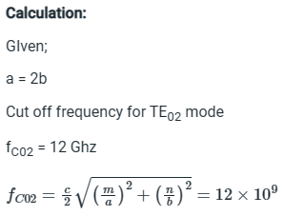

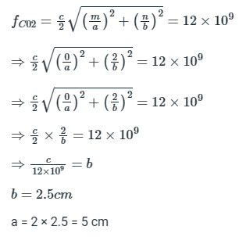

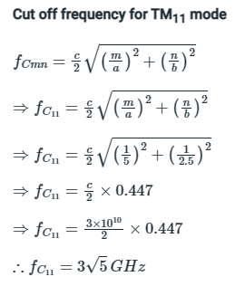

1. **Optical Fiber Sources and Detectors**

**MCQ-1**

A device which converts electrical energy in the form of a current into optical energy is called as ___________

1. Optical source
2. Optical coupler
3. Optical isolator
4. Circulator Solution: 1.

Explanation: An Optical source is an active component in an optical fiber communication system. It converts electrical energy into optical energy and allows the light output to be efficiently coupled into the Optical fiber.

**MCQ-2**

The radiation emission process (emission of a proton at frequency) can occur in __________ ways.

1. Two
2. Three
3. Four
4. One Solution: 1.

Explanation: The emission process can occur in two ways. First is by spontaneous emission in which the atom returns to the lower energy state in a random manner. Second is by stimulated emission where the energy of a photon is equal to the energy difference and it interacts with the atom in the upper state causing it to return to the lower state along with the creation of a new photon.

**MCQ-3**

Which process gives the laser its special properties as an optical source?

1. Dispersion
2. Stimulated absorption
3. Spontaneous emission
4. Stimulated emission

Solution: 4.

Explanation: In Stimulated emission, the photon produced is of the same energy to the one which cause it. Hence, the light associated with stimulated photon is in phase and has same polarization. Therefore, in contrast to spontaneous emission, coherent radiation is obtained. The coherent radiation phenomenon in laser provides amplification thereby making laser a better optical source than LED.

**MCQ-4**

_______________ occurs as a result of the change in lasing frequency with gain.

1. Frequency multiplication
2. Dispersion
3. Attenuation
4. Line-width broadening

Solution: 4.

Explanation: Line-width broadening is a fundamental consequence of spontaneous emission process. It is related to the fluctuations in the phase of the optical fields. These phase fluctuations are due to the phase noises associated with the spontaneous emission process.

**MCQ-5**

The mechanism which results from a refractive index change in the passive waveguide layer is called as ___________.

1. Absorption
2. Spontaneous emission
3. Monolithic inversion
4. Bragg wavelength control

Solution: 4.

Explanation: A wider wavelength tuning length is obtained by separating the Bragg region in the passive waveguide and by introducing a phase region within a waveguide control mechanism provides phase control. It takes place by some changes in a passive waveguide layer.

**MCQ-6**

____________ converts the received optical signal into an electrical signal..

1. Detector
2. Attenuator
3. Laser
4. LED

Solution: 1.

Explanation: A detector is an essential component of an optical fiber communication system. It dictates the overall system performance. Its function is to convert optical signal into an electrical signal. This electrical signal is then amplified before further processing.

**4. Light Propagation in Optical Fiber, Types of Fiber based on refractive index profile and mode of transmission**

1. Multimode step index fiber has ___________

a) Large core diameter & large numerical aperture

b) Large core diameter and small numerical aperture

c) Small core diameter and large numerical aperture

d) Small core diameter & small numerical aperture

Answer: a

Explanation: Multimode step-index fiber has large core diameter and large numerical aperture. These parameters provides efficient coupling to inherent light sources such as LED’s.

2. Multimode graded index fibers are manufactured from materials with ___________

a) Lower purity

b) Higher purity than multimode step index fibers.

c) No impurity

d) Impurity as same as multimode step index fibers.

Answer: b

Explanation: Multimode graded index fibers have higher purity than multimode step index fiber. To reduce fiber losses, these fibers have more impurity.

3. The performance characteristics of multimode graded index fibers are ___________

a) Better than multimode step index fibers

b) Same as multimode step index fibers

c) Lesser than multimode step index fibers

d) Negligible

Answer: a

Explanation: Multimode graded index fibers use a constant grading factor. Performance characteristics of multimode graded index fibers are better than those of multimode step index fibers due to index graded and lower attenuation.

4. Single mode fibers allow single mode propagation; the cladding diameter must be at least ___________

a) Twice the core diameter

b) Thrice the core diameter

c) Five times the core diameter

d) Ten times the core diameter

Answer: d

Explanation: The cladding diameter in single mode fiber must be ten times the core diameter. Larger ratios contribute to accurate propagation of light. These dimension ratios must be there so as to avoid losses from the vanishing fields.

5. A fiber which is referred as non-dispersive shifted fiber is?

a) Coaxial cables

b) Standard single mode fibers

c) Standard multimode fibers

d) Non zero dispersion shifted fibers

Answer: b

Explanation: A standard single mode fiber having step index profile is known as non-dispersion shifted fiber. As these fibers have a zero dispersion wavelength of 1.31μm and so are preferred for single-wavelength transmission in O-band.

6. Optical fibers for communication use are mostly fabricated from ___________

a) Plastic

b) Silica or multicomponent glass

c) Ceramics

d) Copper

Answer: b

Explanation: Silica or a compound of glass are brittle and have almost perfect elasticity until reaching their breaking point. Strength of these materials is high. Thus, optical fibers are fabricated from these materials.

**5. Nonlinearity and dispersion in optical signal transmission**

1. ___________ measurements give an indication of the distortion to the optical signals as they propagate down optical fibers.

a) Attenuation

b) Dispersion

c) Encapsulation

d) Frequency Answer: b

Explanation: Dispersion measurements provide the exact parameters to truly determine the quality and degradation to the optical signals. It gives an indication of the distortion to the optical signals as they propagate down the optical fibers.

2. The measurement of dispersion allows the _________ of the fiber to be determined.

a) Capacity

b) Frequency

c) Bandwidth

d) Power Answer: c

Explanation: Dispersion measurements give an indication of distortion, which in turn determines the information carrying capacity of the fiber. This information carrying capacity of the fiber is purely dependent on the bandwidth of the fiber.

3. Intermodal dispersion is nonexistent in ________ fibers.

a) Multimode

b) Single mode

c) Step index- multimode

d) Al-GU

Answer: b

Explanation: Intra-modal as the name suggests need multimode fibers to propagate. In single mode fibers, only one mode is there to propagate. Hence, Intermodal dispersion is nonexistent in single mode fibers.

4. In the single mode fibers, the dominant dispersion mechanism is ____________

a) Intermodal dispersion

b) Frequency distribution

c) Material dispersion

d) Intra-modal dispersion

Answer: d

Explanation: In single mode case, the dominant dispersion mechanism is chromatic. Chromatic dispersion is called as intra-modal dispersion.

5. The time domain dispersion measurement setup involves _____________ as the photo detector.

a) Avalanche photodiode

b) Oscilloscope

c) Circulator

d) Gyrator

Answer: a

Explanation: The time domain fiber dispersion measurement involves the pulses to be received by the photo detector in order to determine the distortion in the optical signals. These pulses are received by avalanche photodiode.

6. Rayleigh scattering and Mie scattering are the types of _____________

a) Linear scattering losses

b) Non-linear scattering losses

c) Fiber bends losses

d) Splicing losses

Answer: a

Explanation: Rayleigh scattering and Mie scattering both result from non-ideal physical properties of the fiber. These losses may be impossible to eradicate. Linear scattering mechanisms cause the transfer of optical power contained within one propagating mode to be transferred linearly into a different mode.